

**COMSATS University Islamabad (CUI)**

Project Proposal  
(SCOPE DOCUMENT)

for

**<PROJECT NAME>**  
Version 1.0

***By***

**Student Name 1 CIIT/SP09-BCS-xxx/ISB**

**Student Name 2 CIIT/SP09-BCS-xxx/ISB**

***Supervisor*Supervisor Name**

***Co-Supervisor (if any)*C0-Supervisor Name**

*Bachelor of Science in Software Engineering (20xx-20xx)*

**SCOPE DOCUMENT REVSION HISTORY**

|  |  |  |
| --- | --- | --- |
| **No.** | **Comment** | **Action** |
|  |  |  |
|  |  |  |
|  |  |  |
|  |  |  |
|  |  |  |
|  |  |  |

**Supervisor Signature:**

**Date:**

**Table of Contents**

Abstract i

1. Introduction ii

2. Problem Statement ii

3. Problem Solution for the Proposed System ii

4. Related System Analysis/Literature Review ii

5. Advantages/Benefits of Proposed System iii

6. Project Scope iii

7. Modules iv

7.1 Module 1: Module Name v

7.2 Module 2: Module Name v

8. System Limitations/Constraints v

9. Software Process and Design Methodology v

10. Tools and Technologies v

11. Project Stakeholders and Roles vi

12. Team Members Individual Tasks/Work Division vi

13. Data Gathering Approach vii

14. Concepts vii

15. Gantt Chart vii

16. Mockups viii

17. Conclusion x

18. References x

19. Plagiarism Report x

# 

**Project Category: (**Select all the major domains of proposed project**)**

* **A-**Desktop Application/Information System **B-**Web Application/Web Application based Information System  **C-** Problem Solving and Artificial Intelligence ** D-**Simulation and Modeling ** E-** Smartphone Application  ** F-** Smartphone Game ** G-** Networks ** H-** Image Processing  **I-** Industrial Project  **J-** Academia Project
* **O-** Other (specify category) ___________________

# Abstract

Provide a one to two paragraph summary of the targeted project. The abstract should give an idea of **what** the targeted project is trying to achieve. Think of your abstract as a **condensed version** of targeted whole project. By reading it, the reader should **understand the nature of the targeted project**. It should be comprehensive, and concise. You may visit the following link for a good understanding about writing a high-quality abstract:

<https://www.projecttopics.org/write-abstract-final-year-project.html>

**The abstract SHOULD NOT contain:**

* Lengthy background or contextual information
* Redundant phrases, unnecessary adverbs and adjectives, and repetitive information
* Acronyms or abbreviations
* References to other literature [say something like, "current research shows that..." or "studies have indicated..."]
* Using ellipticals [i.e., ending with "..."] or incomplete sentences
* Jargon or terms that may be confusing to the reader
* Citations to other works
* Any sort of image, illustration, figure, or table, or references to them.

# Introduction

Specify the purpose of the targeted project along with detailed background description of the system. This is very important section of the report. So, through effective writing you may introduce the targeted project in an effective manner.

Usually, “Introduction” section can be described by using **10-12 sentences**; however, the student can describe it more than 12 sentences.

The following URL is useful for some basic information about writing an Introduction section.

<https://www.projecttopics.org/write-introduction-final-year-project.html>

# Problem Statement

This is core section of scope document. It mainly focuses on mentioning the core targeted problem that drives on the development of the project. The FYP-0 student may focus on the following questions to write an effective problem:

* **What** problem does the proposed system solve?
* **Why** you are developing this system?
* **Does** the same system already exist? **If** yes, how will a re-implementation aid your learning?
* **What** skills do you expect to learn from this project?

It is suggested to check it online that how to write a quality problem statement. At the same time, students may consult the previous FYP final reports to refine their problem statement. The following URL helps in writing a quality problem statement:

<https://www.wikihow.com/Write-a-Problem-Statement>

# Problem Solution for the Proposed System

Briefly explain how your proposed system solves the problems as mentioned in the Problem Statement. May be, the proposed system provides a more cost-effective solution than the existing systems. Therefore, it is required to explicitly mention the logic of the proposed system, which provides additional benefits in contrast to the existing systems. The problem solution can be usually describe using **14-16 sentences.**

# Related System Analysis/Literature Review

This section discusses about the existing/similar systems related to the proposed project. At least three existing systems should be discussed. However, there might be only one or no system exist. In this situation, discuss the related system, accordingly. Briefly explain the related system analysis, which help to explicitly specify the contribution of the proposed project.

You may use a single paragraph to explain a similar (related) single system/application. However, the explanation for a similar single system/application should not be more than 5 sentences.

**Note** that the Research-based projects may provide literature review instead of related system analysis.

You must cite the Tables/ Figures as presented in this document. For example, Table 1 presents the related system with the targeted project solution.

Table 1: Related System Analysis with Targeted Project Solution.

|  |  |  |
| --- | --- | --- |
| **Application Name** | **Weakness** | **Proposed Project Solution** |
| * The name of related application(s). | * Weaknesses may include limited features, low quality functionality and processes. | * The way the proposed project mitigates the weaknesses. |

# 

# Advantages/Benefits of Proposed System

This section explicitly mentions the advantages and benefits of the proposed system. In other words, it is required to discuss advantage of the proposed solution to the existing problem. Generally, **5-7 advantages** need to be mentioned.

# Project Scope

Write down the scope of the targeted project in a paragraph. Briefly define the main functionalities of the proposed project. Scope defines the boundaries and range of the proposed solution, i.e. what would be the part of the targeted project and what will be not. Write down in logical flow with consistency. Usually, **14-18** sentences are enough to succinctly discuss the scope of the proposed system.

Context diagram is widely used to define and clarify the boundaries of the software system. So, present a context diagram to model the scope of the targeted project. Figure 1 depicts the context diagram of a cafeteria ordering system.

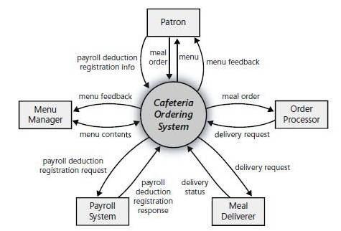

**Figure 1: Context Diagram of the Targeted Project.**

# Modules

Write down the modules of the targeted project. Do not forget to mention special/new features. Briefly explain the identified module using 6 to 8 sentences.

**Note** that for a group of 2 student’s project, usually 6-8 Modules are expected. Similarly, 9-11 modules are expected for a 3 student’s project.

**Explanation of a Module**: Module is a section of a program that performs a task. Programs consist of [modules](http://www.webopedia.com/TERM/M/module.html), each of which contains one or more routines. The term routine is synonymous with procedure, function, and subroutine.

**Example:**

Enterprise resource planning (ERP) software - is comprised of several large modules (for example, finance, supply chain and payroll, etc.), which may be implemented with little or no customization.

Briefly explain each of the modules of the targeted project with respect to major functionality in a user context.

## Module 1: Module Name

Brief description…

## Module 2: Module Name

Brief description…

# System Limitations/Constraints

Write down the main limitations and constraints of the targeted project. Generally, **2-4 constraints** need to be mentioned.

# Software Process and Design Methodology

Write down your adopted software methodology/software process that will be used for project development. Also, mention why you have chosen this methodology. The rationale of selecting the methodology should be clearly justified. May be **10-12 sentences** are sufficient.

* Mention the software process methodology you will use for your project e.g. Incremental process method.
* Also Mention the software design methodology you will use for your project e.g. Object-oriented Methodology, or Procedural methodology
* Obviously, the choice of design methodology will affect choice of tools and technologies.
* Choice of methodology will affect nature of design (SDS).
* Choice should be made depending on your expertise and your needs, e.g., most simulation and device level software can only be programmed in procedural languages.

# Tools and Technologies

Explicitly mention the hardware/software tools and technologies with version number, which would be used in implementation. It is also expected to mention about the APIs, language(s), SDK(s) etc. which will be used for implementation of the targeted project. After briefly discussing the used tools/technologies (**3-5 sentences**), present the information using a tabular format.

Table 2: Tools and Technologies for the Targeted Project.

|  |  |  |  |
| --- | --- | --- | --- |
| **Tools**  **And**  **Technologies** | **Tools** | **Version** | **Rationale** |
| MS Visual Studio | 2015 | IDE |
| MS SQL Server | 2015 | DBMS |
| Adobe Photoshop | CSC 6 | Design Work |
| MS Word | 2015 | Documentation |
| MS Power Point | 2015 | Presentation |
| Pencil | 2.0.5 | Mockups Creation |
| **Technology** | **Version** | **Rationale** |
| C# | 6.0 | Programming language |
| SQL | 2013 | Query Language |
| Html | 5 | Web Development |

# Project Stakeholders and Roles

Write down the key project stakeholders along with their assigned roles. The discussion should be of 1-2 paragraphs (**2-4 sentences).** Table 3 presents the project stakeholders for the targeted project.

Note: cutting of diagrams/ Tables is not allowed. In this case, move the diagram/table to the next page.

Table 3: Project Stakeholders for the Targeted Project.

|  |  |
| --- | --- |
| **Project Sponsor** | **All web applications and desktop applications should have real client.**  **Mention the sponsor of the targeted project.**  **Default option will be: COMSATS University Islamabad** |
| **Stakeholder** | Mention your stake holders with their roles and responsibilities.  Default option will be   * Students names * Project Supervisor Name: Dr./Mr./Miss … * Final Year Project Committee: Evaluation of project |

# Team Members Individual Tasks/Work Division

Explicitly discuss the work division among the team members. Optionally, you may provide the reasoning of the task allocation between/among the team members.

Table 4: Team Member Work Division the Targeted Project.

|  |  |  |
| --- | --- | --- |
| **Student Name** | **Student Registration Number** | **Responsibility/ Modules** |
| * **Student 1 Name** | * **Registration Number (Student 1)** | * **Describe the work division of each student along with modules**   **E.g.**  **Mr. Ali (Module1-Module3)**  **Augmented reality and Databases tasks.** |

# Data Gathering Approach

Write down the information and requirement gathering/elicitation approaches for the targeted project, e.g., Interview, Questionnaire etc. It is also expected to justify the selection of the information and requirements gathering approach. In other words, why your selected approach is effective in your project context? You may discuss each of the employed information/requirements gathering approach in a paragraph format (**contain 3-4 sentences**).

# Concepts

Mention the concepts that you will learn while doing the targeted project. For example: Augmented Reality, Virtual Reality, Algorithms, API’’s Code injection, Closures, VI technique etc. Not more than 4 sentences for each of the concept. It is expected to briefly mention at least 3-5 concept.

The following is a general template to discuss each of the concept.

**Concept-1:** Concept Name E.g. Augmented Reality (Briefly give the overview of concept with respect to the targeted project).

# Gantt Chart

Create the Gantt Chart and provide estimated start and end dates of all proposed modules/tasks for each team member. Also, identify the dependencies (which tasks cannot be started/completed, until the dependent task is completed). Gantt chart can be created using MS Project. Semester calendar can be useful to develop the Gantt Chart.

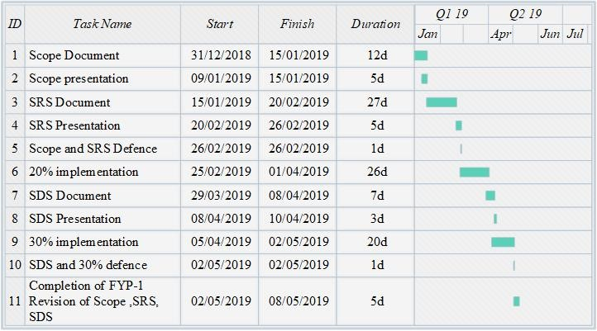

Figure 1: Gant Chart of the Targeted Project.

# Mockups

It is required to depict the design mockups (**at least 6-8**) in accordance with the core modules as mentioned in the Scope Section. Do not include mockups for Login, Signup, Forgot Password, Contact Us, About Us etc. If the project is a Web or a Smartphone Application, then include at-least three mockups from each part of the targeted project. You can design mockup in any design tool for example pencil tool ([<https://pencil.evolus.vn/>](https://pencil.evolus.vn/) ) or Balsamiq (<https://balsamiq.com/>) or Justinmind (<https://www.justinmind.com/>).

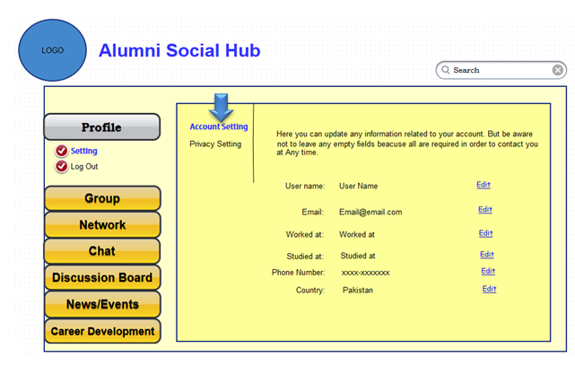

**Mockup-01 -Design Mockup for Account Setting.**

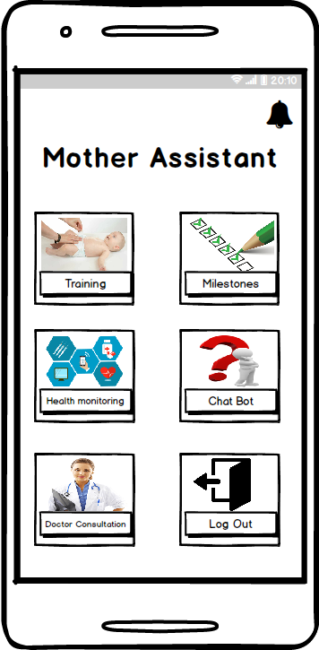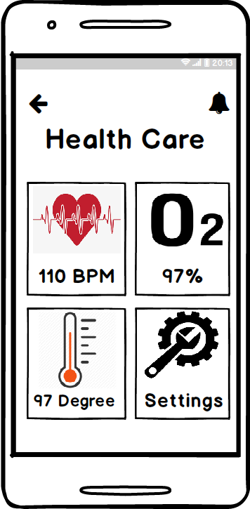

**Mockup2: Dashboard Mockup3: Health Statistics**

# Conclusion

Conclude this document and the targeted project. Usually, one to two paragraphs **(4-5 sentences).**

# References

References to any book, journal paper or website should properly be acknowledged. Please consistently follow the style. The following are few examples of different resources i.e. journal article, book, and website.

* 1. Lyda M.S. Lau, Jayne Curson, Richard Drew, Peter Dew and Christine Leigh, (1999), Use of VSP Resource Rooms to Support Group Work in a Learning Environment, ACM 99, pp-2. (**Journal paper example**)
  2. Hideyuki Nakanishi, Chikara Yoshida, Toshikazu Nishmora and TuruIshada, (1996), FreeWalk: Supporting Casual Meetings in a Network, pp 308-314 (paper on web) http://www.acm.org/pubs/articles/proceedings/cscw/240080/p308-nakanishi.pdf
  3. Ali Behforooz& Frederick J. Hudson, (1996), Software Engineering Fundamentals, Oxford University Press. Chapter 8, pp255-235. (**book reference example**)
  4. Page Author, Page Title, http://www.bt.com/bttj/archive.htm, Last date accessed. (**web site**)

# Plagiarism Report

Attach the Plagiarism report of the targeted project scope document from library staff of turnitin tool (<http://turnitin.com>).